Auto Ticket Classification using Flow Designer
Part 7 of 7 — Deployment & ConclusionPart 7 of 7 — Deployment & Conclusion

Phase 5: Deployment & Final Documentation
The objective of this phase is to deploy the developed solution to the target environment and finalize all project documentation. This phase ensures that the solution is stable, reusable, and ready for demonstration or production use, along with complete and clear documentation for future reference.

Activity 1: Make Update Set to Complete State
- Go to All menus → Search For Local Update Sets.
- Under System Update sets, select → Local Update sets.
- Open the Project Update set.
- Make the State from In progress to Complete.
- Then Save the Form.
- Under Related links, click Export to XML Option.
- Then the XML format of the Update set data will be downloaded to your system.
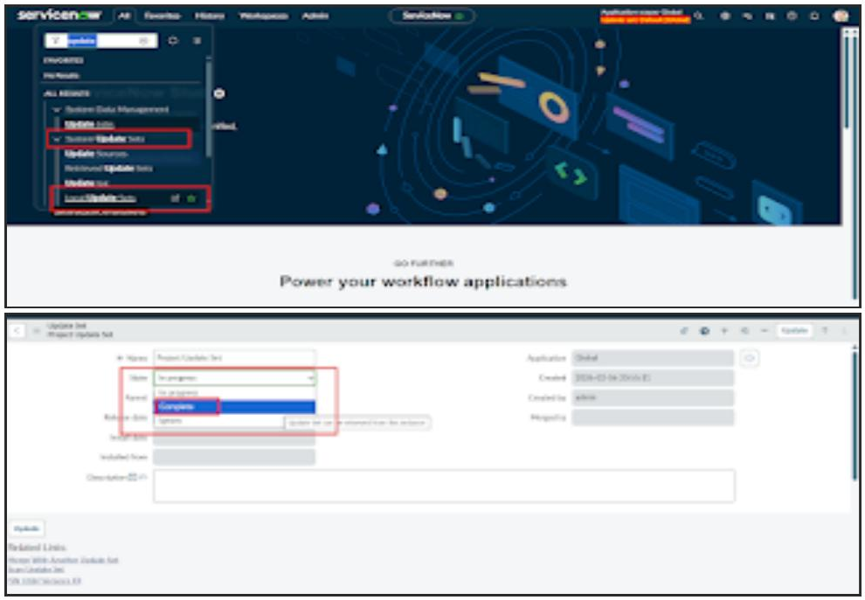
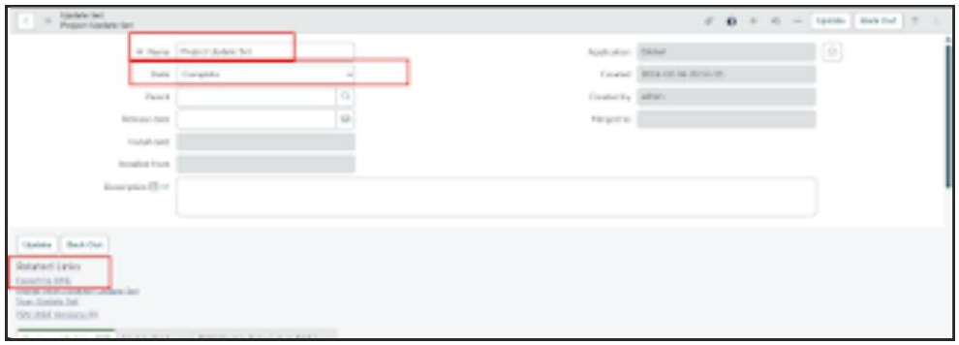
- We can share the downloaded file through WhatsApp or Mail.
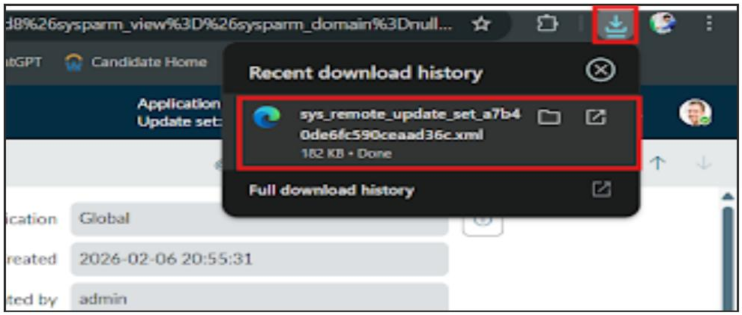

Conclusion
The Auto Ticket Classification using Flow Designer project successfully delivers a complete, end-to-end automation solution for a school IT helpdesk. The primary objective of reducing manual effort in ticket categorization and improving response efficiency has been fully achieved.
Through structured requirement analysis, careful backend configuration, and no-code automation using Flow Designer, the system now automatically classifies IT tickets based on the short description provided by students. The implementation of dependent choice fields ensures data accuracy, while automated email notifications improve communication by instantly acknowledging ticket creation to the caller.
The solution was developed using a phased approach, ensuring clarity, stability, and ease of maintenance. Comprehensive testing and security validation confirmed that the system functions reliably, maintains data integrity, and enforces appropriate access controls.
Overall, this project demonstrates how ServiceNow can be effectively used to build scalable, maintainable, and user-friendly automation solutions without relying on complex scripting or machine learning. The design is well-suited for small to medium environments such as educational institutions and can be easily extended in the future to include advanced features like assignment automation, SLA tracking, or predictive intelligence.

